AUTHOR FROM SCRATCH S3 NOTIFICATION AND OBJECT

1-create a lambda function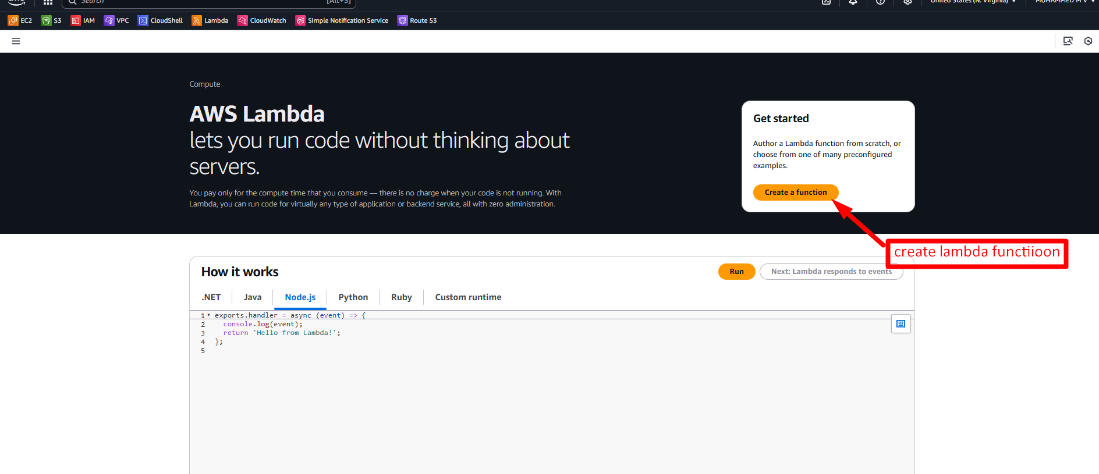2-select author from scratch and name select python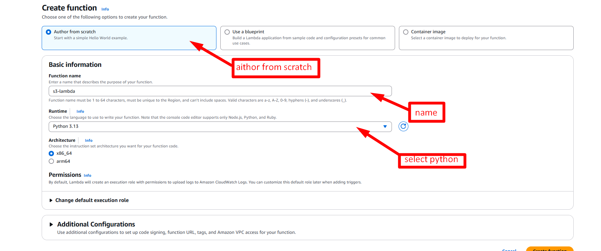3-create new role from aws policies template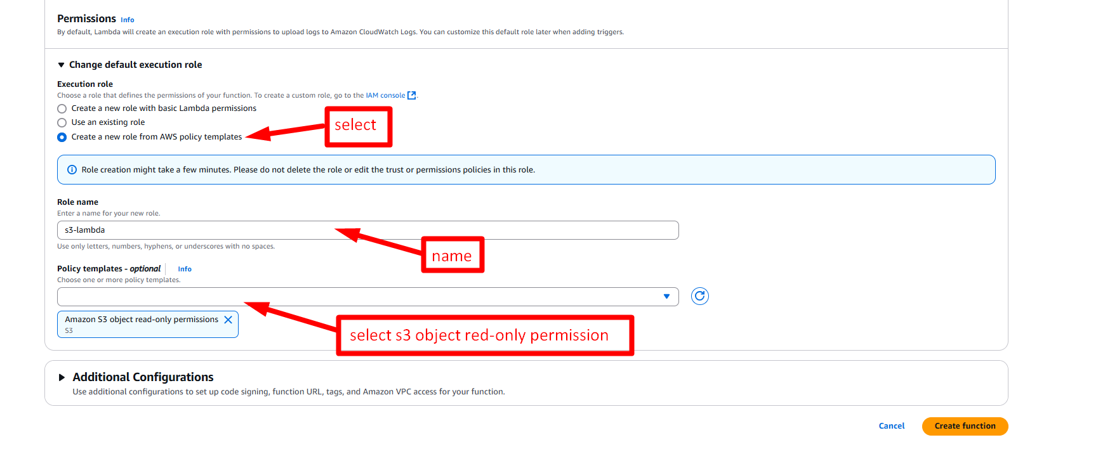

4-create a bucket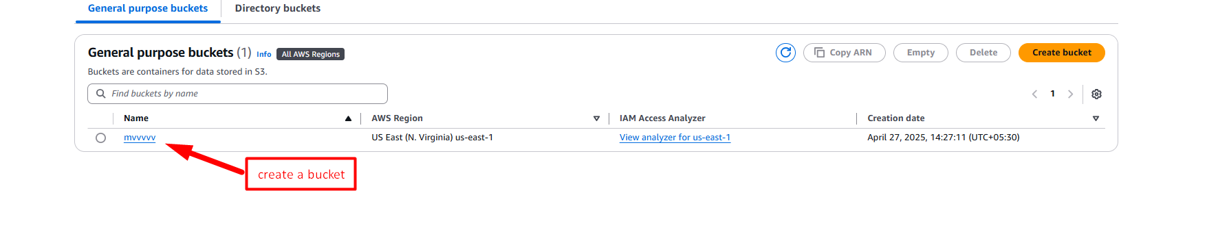5-go to properties and create event notification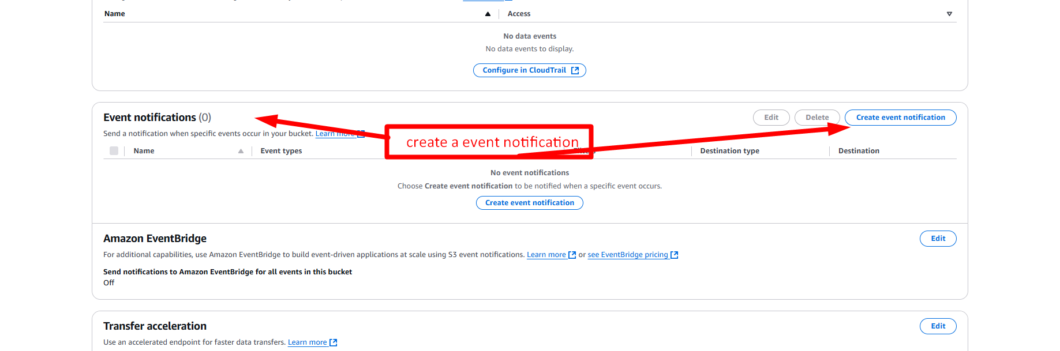6-name,event type 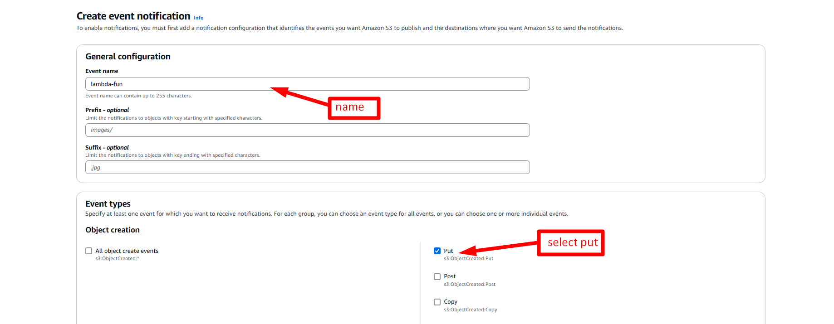7-select the lambda function and save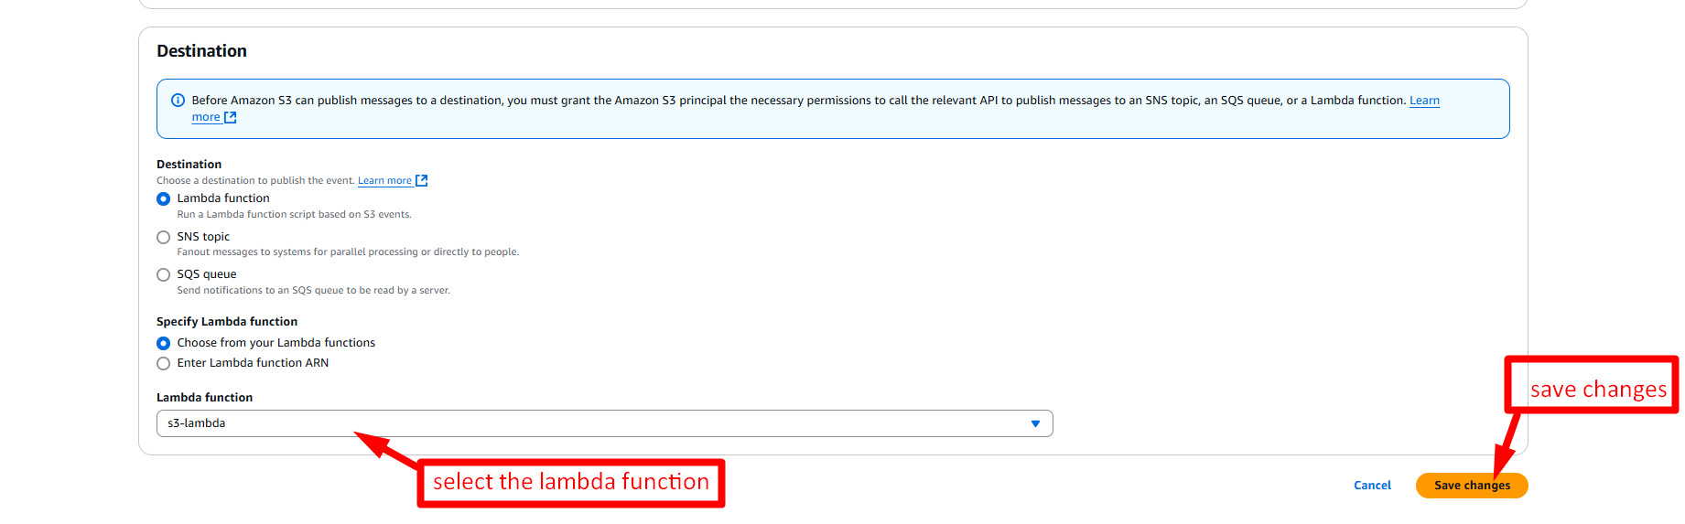

8-go back to lambda and create sns success and failure notification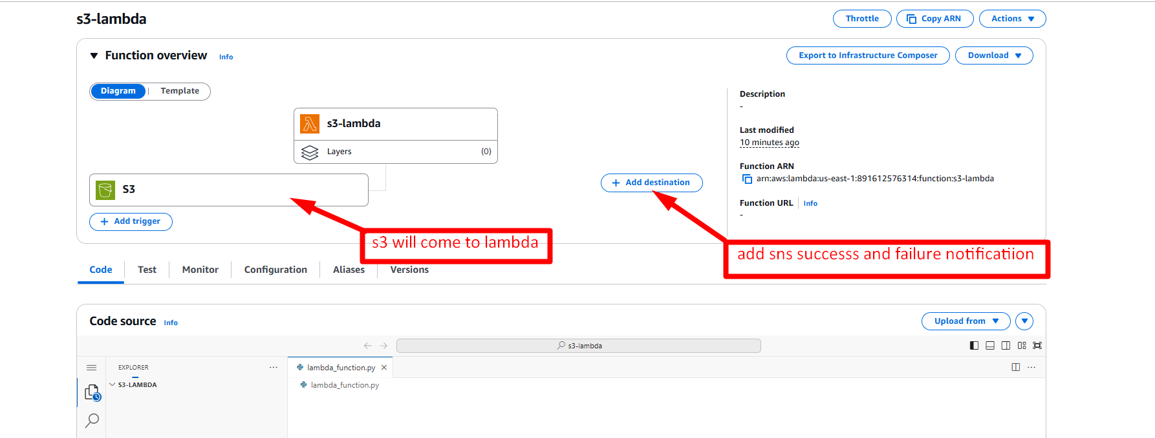9-go to s3 bucket and upload anthing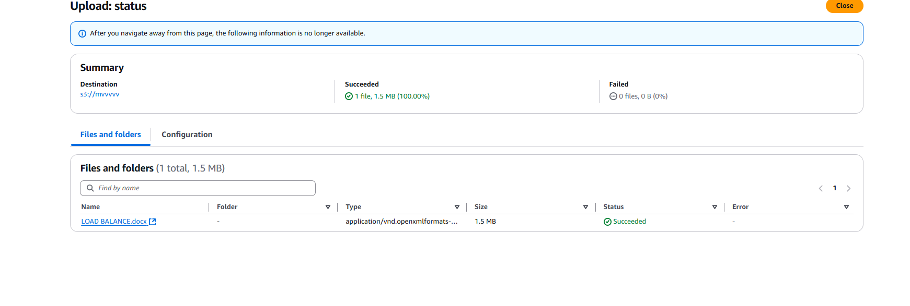10-view cloudwatch lods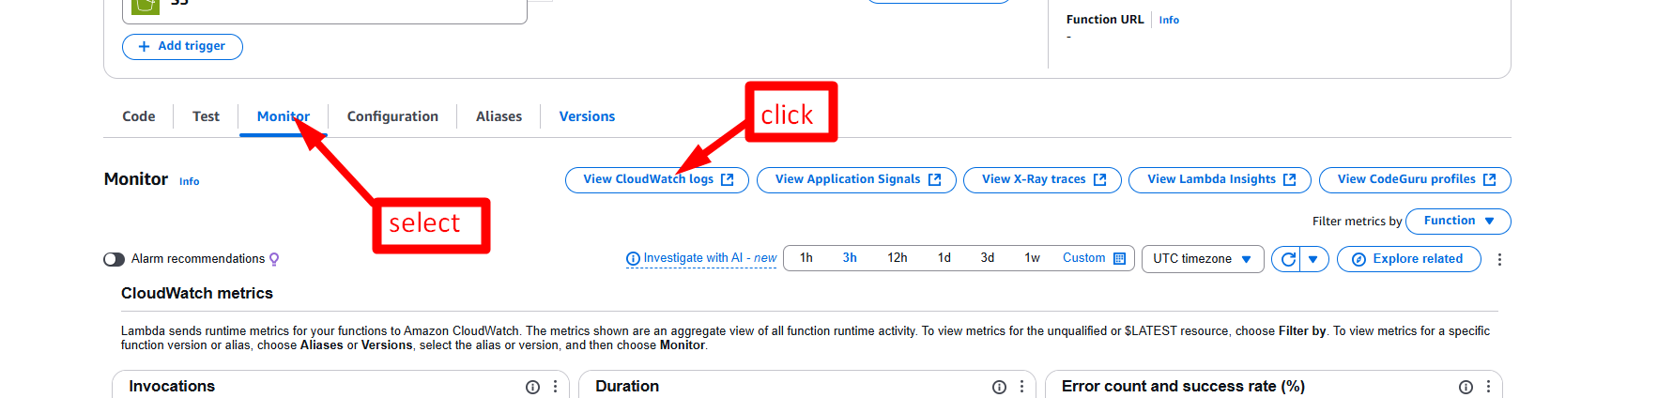11-select the log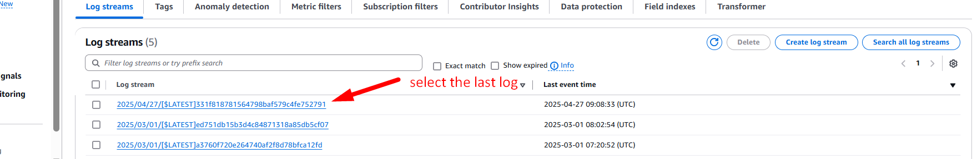

12-it show the logs